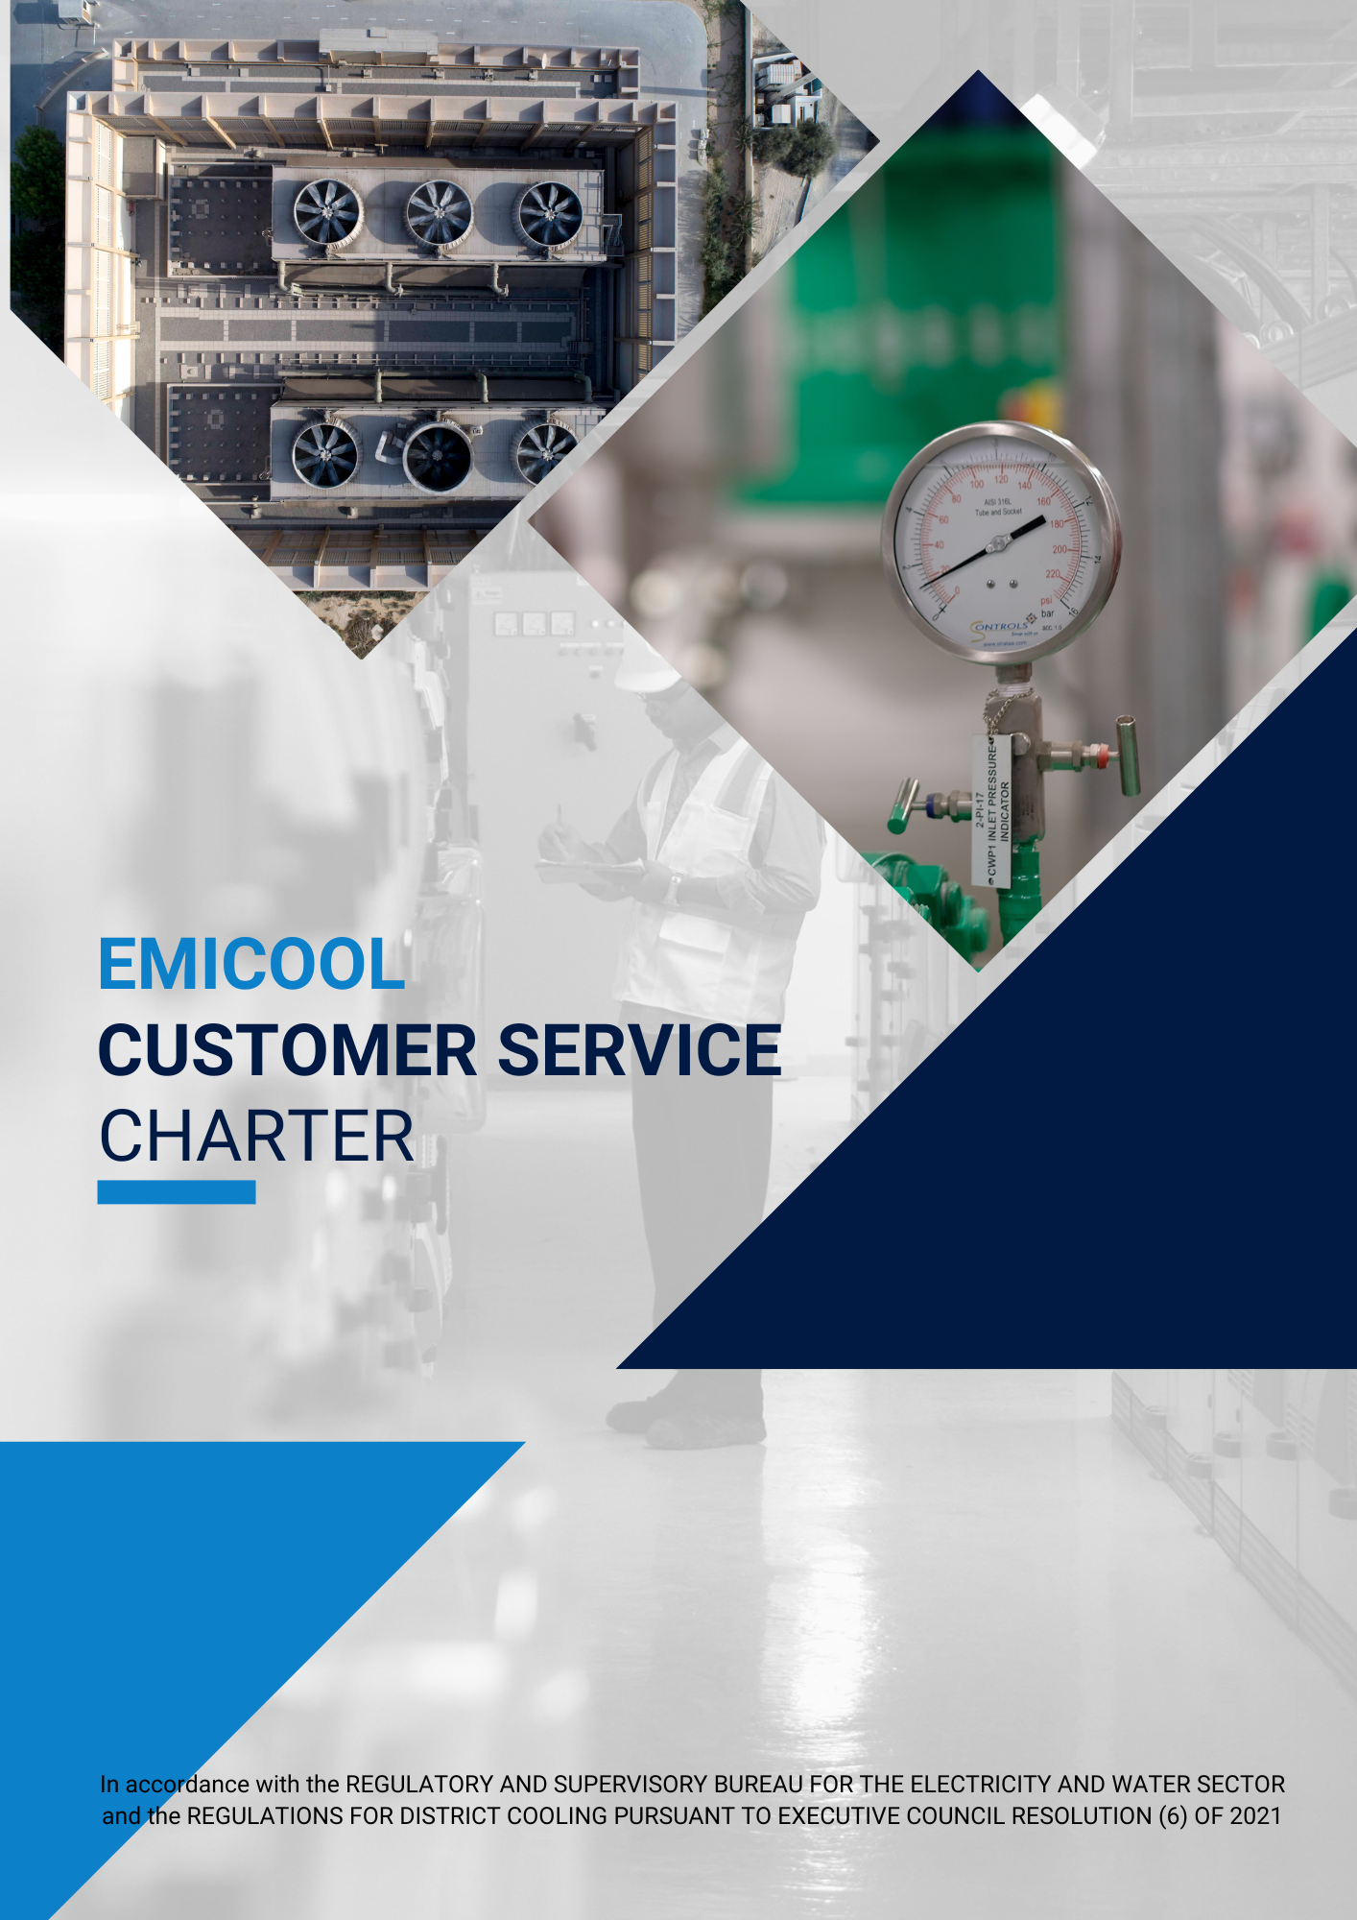

Who We Are – Our Vision and Mission
EMICOOL is a leading district cooling service provider in the UAE with approximately 20% market share. With 355,000 tons of refrigeration (TR) capacity, it serves more than 30,000 happy customers.
Vision: To be recognized as a world-class provider of reliable and efficient district cooling.
Mission: To continuously exceed customer expectations in delivering district cooling services. Our motivated and competent workforce shall deliver such services reliably, safely and efficiently. We will utilize resources responsibly while caring for the environment.

Our Commitment to You
In our efforts to provide you with unparalleled service, we commit to:
- Provide and maintain prompt, effective and efficient customer service
- Assuring high-quality of service with better interaction
- Maintaining a professional and respectful manner in all our dealings with you.
- Treating you fairly and impartially, irrespective of your religious beliefs gender political opinion, race, age, marital status or any other factor.
- Having staff who are fully trained to carry out their duties effectively and efficiently.
- Ensuring appropriate confidentiality in all our dealings.
- Sharing valuable energy-saving tips to help you save money
- Consulting you regularly and taking account of your comments through surveys.
- Aiming to continuously improve our services for the benefit of our customers.
- Being easily accessible and communicable
- Resolving Customers’ issues and answering their enquiries efficiently

Your Commitment to Us
In order to enable us to serve you better, we would appreciate your commitment to:
- Keep us updated with your latest details
- Providing necessary information and relevant documents when seeking services
- Refer to previous correspondences to help us respond to you promptly
- Provide your valuable feedback on the quality and timeliness of our services

Services Provided by Us
- Tenant Registration requests
- Tenant Disconnection requests
- Ownership Transfer requests
- Load Increase requests
- Reconnection requests
You can request the above services through any of our following channels:
- Visit our Office (DIP/DMC/Mirdif Uptown/DAMAC and DWTC)
- E-mail at customercare@emicool.com
- EMICOOL Customer Portal(if access is available)

We also provide Express Service for Registrations, Disconnections and Transfers to cater to urgent requirements:

- Service availability locations: EMICOOL Customer Service Centre in (DIP/DMC/Mirdif Uptown/DAMAC and DWTC)
- Mandatory requirements: settlement of all previous outstanding, final bill request supported with mandatory documentation as per the requirement list
- Timeline: Final bill will be generated for you within 3 working hours from the time of Express Service Application received by Customer Service
- Express Service facility timings: 8 AM to 3 PM Monday to Thursday and 8 AM to 10 AM on Fridays excluding public holidays

Schedule of Fees, Deposits and Fines

Service | Fees +VAT
Activation Fees | AED 250
Reconnection Fees | AED 100
Late Payment Fees (for every occurrence)  Penalty charges may be applied to a customer’s account up until seven (7) calendar days after the due date. | AED 100
Express Service Fees (to be charged in addition to the normal Fees) | AED 500
Bank transfer fees | AED 100
Cheque re-issuance fees | AED 100
Return cheque fees | AED 100

Monthly Billing
Billing Service Agreement: Any new connection shall be accompanied and governed by a Billing Service Agreement, which will be issued by EMICOOL to the Customer. The Customer shall be required to sign the Agreement prior to receiving a chilled water connection.
Monthly Invoice: We shall submit to you a detailed monthly Invoice of your chilled water consumption.
The Customer is required to settle the Invoice amount on/before the Due Date (which would be 14 days after the Invoice Date).
Late Payment Fee: If the Customer fails to pay within 21 days of the due date, EMICOOL reserves the right to charge the Customer with a penalty of AED 100 (+ VAT). Late Payment Fee shall only be applied in case the total overdue amount exceeds AED 250.
Suspension: If the Customer fails to pay after the lapse of the Final Notice Period (which will be 14 days after submission of Final Notice), EMICOOL reserves the right to suspend the Customer’s connection.
Reconnection: The Customer may apply for reconnection, only after the settlement of all outstanding dues, including the Reconnection Fee.

How to Pay
- Customer Service: Customers can make a payment at EMICOOL Office. Preferred payment method is via debit/credit card. We have offices in DIP/DMC/Mirdif Uptown and DAMAC
- Online Payment: Customers can make a payment using Online Customer Portal. Click here to see the guide on how to make a payment.
- Bank Transfer: Customers can make a payment through Bank Transfer. Click here for EMICOOL Bank account details.
- Mobile Payment: Payment can be made through EMICOOL mobile application. Download it by clicking here for iOS devices and here for Android devices. Click here to see the guide on how to make a payment.
- Quick Pay: Now it is much easier to pay EMICOOL bills without logging in. Just enter the valid EMICOOL contract number (ECXXXXXX), follow the instructions and click pay. Click here to see the guide

Our Complaints Handling Procedure
We always strive to provide our customers with the best service. Unfortunately, if something has gone wrong, by telling us about it will give us the opportunity to put things right and make improvements. Our Complaints Handling Procedure lets you know what you can expect if you are not satisfied with a service you have received from us.
We follow a 3 stage complaints process, so in the event you are unhappy about our service you can raise your complaint with our customer service team via a number of options we offer:
- In writing by email
- By telephone through our call centre
- In person by visiting one of our offices

What we need from you
When you contact us, we need you to provide us with as much details as possible. This will help us to understand the issue and resolve it quickly. Please include:
- Your name and up to date contact details
- Your Contract reference number if you have it
- Which part of the service you are complaining about
- A description of your complaint and how it has affected you
- When the issue happened

We need this information to fully understand what has gone wrong so we can make sure the right person is handling your complaint, in order for them to investigate and resolve your issue as soon as possible.

Stage 1: Review by our Customer Service Team
Upon receiving your complaint, we will acknowledge it within one working day. We will then investigate your complaint thoroughly and give you a detailed response within six working days of receipt. If we are unable to give you a detailed response within this time, or we need more time to complete our investigation, we will:
- Give you an initial written response within six working days of receipt. This initial response will give you details of who you can contact about your complaint and will also inform you when to expect a more detailed response.
- We will also keep you informed of progress and if we need to take further action to put things right, we will do our best to complete our work promptly
- Provide you with a detailed response within ten working days of receipt giving you a full explanation addressing the issues that you have raised and taking appropriate action to put things right.

Stage 2: Referral to a senior team member
If you’re not happy with the way our Customer Services Team has dealt with your complaint, then you can request for the matter to be escalated to a senior team member. They will investigate your situation further and work with you to put things right. There is a dedicated email contact for complaints escalated to stage 2 which is monitored by a Customer Success Lead, who will personally handle and investigate your complaint to determine why our resolution was not satisfactory for you and whether there was anything further we could have done to resolve your issue.

Stage 3: Final Review by our Executive Team
If you’re still not fully satisfied after referring the matter to a senior team member, you can ask for your complaint to be raised for a formal appeal to our Executive Office and our Senior Customer Service Operations Lead will get in touch with you within one working day acknowledging your appeal and will investigate further to determine if correct processes have been followed. If in the event, we find that correct process was not followed to resolve your complaint at both stage 1 and 2, we aim to offer a resolution within six working days. There is a dedicated email contact for you to lodge your appeal at stage 3, which is monitored by our Senior Customer Service Operations Lead from the Executive Office.
If there are any delays, we will promptly inform you and let you know when you can expect a full response. The complaint cannot progress to the next stage until the previous stage has been exhausted by the customer.

How we record your complaint
Upon contacting us, we record details of your complaint on our system under your Contract Number and record the nature of your complaint. We issue you with a reference number to keep track of the complaint and ensure it is dealt with the correct department and as promptly as possible.
For emergency cooling related complaints such as:
- No cooling
- Water Leakage
Please contact us at our 24/7 Emergency Number 04-8160200. We aim to resolve the issue within 24 hours

For other cooling related complaints such as:
- High cooling
- Low cooling
Please follow the process outlined in the flowchart on the next page.

For all other complaints such as:
- Bills
- Connection related complaints
- Any other general complaints
Please follow the process outlined in the flowchart on the next page.

Enquires
If you have an enquiry about our service, our processes, your bill or any other general enquiry please visit our FAQ page (https://www.emicool.com/en/faq). If your query is not answered via our FAQ page, please contact us by:
- Call Centre (600-534440) (Timings: Every day from 8.00 AM to 12.00 AM)
- E-mail at customercare@emicool.com
- In person at our Office (DIP/DMC/Mirdif Uptown/DAMAC and DWTC)

Key Service Turn-Around Times
Service Requests
Category | Express Service | Normal
Tenant Registration Requests | 3 working hours | 2 Working Days
Tenant Cancellation Requests | 3 working hours | 2 Working Days
Ownership Transfer Requests | 3 working hours | 3 Working Days
Security Deposit Refund | - | 7 Working Days
Reconnection Requests | - | 24 Hours

Note: The indicated time will only be valid if all mandatory requirements for the service have been completed
All our activities are covered by a range of standards set for our service. Some of these standards cover things such as:
- Average resolution time it takes to complete a customer’s request
- The time it takes for us respond to customers complaint

We aim to complete 100% of customers request with in the turnaround times stated above providing all mandatory requirements for the service has been met, as well as respond to 100% of our complaints with in six working days. We will endeavor to publish our annual report on our website, assessing our performance and the progress we have made in implementing our Strategy and service standards we have set ourselves.

Contact Us
- Call Centre: 600-534440 (Timings: Every day from 8.00 AM to 12.00 AM)
- Customer Portal: https://cportal.emicool.com/
- Customer Care: customercare@emicool.com (We shall respond to you within 24 hours)
- 24/7 Emergency Number: 04-8160200 (Only for technical emergency related issues)
- Office Visit: We have offices in DIP/DMC/Mirdif Uptown/DAMAC and DWTC
- Website: https://www.emicool.com/en/contact-us

